**Drought and high grazing pressure cause loss of tree cover in a temperate forest but not transition to a non-forest state**

Authors: Philip Martin1, Adrian C. Newton1, Elena Cantarello1, Paul Evans1.

Journal: Journal of Applied Ecology

1Centre for Conservation Ecology and Environmental Sciences, Faculty of Science and Technology, Bournemouth University, Poole, BH12 5BB, UK.

2Joint Nature Conservation Committee, Monkstone House, City Road, Peterborough, PE1 1JY, UK.

Keywords: forest dieback; regime shift; forest collapse; ecosystem resilience;

Corresponding author email: phil.martin.research@gmail.com

**Summary**

1. There is concern that forest dieback may result in transitions to non-forest states. Positive feedbacks are thought to play an important role in such transitions by creating self-perpetuating shifts in system states.
2. We used statistical models to identify correlates of death and recruitment of the canopy dominant (*Fagus sylvatica* - beech) in a temperate forest site that has been sampled over 50 years and appears to be undergoing transition to grassland. We use these results along with information from the literature to build an individual based model to investigate the impact of positive feedbacks and disturbance on forest persistence.
3. We found that the probability of tree death declined with increasing tree growth rate, but was positively correlated with tree size. Seedling density was negatively related to canopy cover, but sapling density was not related to canopy cover.
4. Contrary to our expectations, inclusion of positive feedbacks in our individual based model did not result in transition to a non-forest state, even when the chance of annual drought was increased four-fold relative to current conditions.
5. Our results suggest that while positive feedbacks may influence both recruitment of juveniles and death of mature trees, the long lifespan of trees can provide a buffer to sudden transitions.
6. **Synthesis and applications:** To enhance forest resilience management should attempt to stop the development of such positive feedback loops. In our study area fencing off forest areas to reduce seedling mortality caused by browsing of ponies and deer may reduce feedbacks related to juvenile death. However, reducing the feedbacks related to mortality of larger trees will be more challenging as these may be related to larger scale drivers relating to climate change.

**Introduction (aim for ~800 words)**

There is widespread concern that in forest ecosystems subjected to an increae in disturbance, increases in tree mortality can potentially result in shifts to treeless states (Reyer *et al.* 2015). Over the past decade research has suggested such shifts may occur in both tropical (Barlow & Peres 2008; Hirota *et al.* 2011) and boreal regions (Scheffer *et al.* 2012) as a result of climate change and anthropogenic disturbances. Forests may be particularly vulnerable to rapid changes because trees are relatively long-lived, immobile organisms, which consequently find it difficult to adapt to a rapid change in environmental conditions (Burrows *et al.* 2011; Seidl *et al.* 2015). Any shift to relatively treeless, non-forest states (defined as areas with less than 40% canopy cover; Sasaki & Putz 2009) would cause loss of forest biodiversity as well dramatic changes in ecosystem function and the provision of ecosystem services (Scholes *et al.* 2014). Owing to these risks, a recent IPCC assessment concluded that forest dieback has the potential to cause major global economic impacts (Scholes *et al.* 2014). However, despite these concerns, there is relatively little known about the mechanisms that cause transition of forests to relatively treeless states (Reyer *et al.* 2015).

Transitions from one ecosystem state to another occur when disturbances (*sensu* Sousa 2001) resulting in death of organisms cause changes to a system from which it fails to recover (Nimmo *et al.* 2015). These disturbances may represent instantaneous or continuous alteration of species abundances, which are respectively referred to as pulse and press disturbances (Bender, Case & Gilpin 1984). Critically, what is considered to be ‘instantaneous’ or ‘continuous’ depends on the generation time of the organisms in an assembly (Shade *et al.* 2012). Theory relating to ecosystem resilience suggests that interactions between different drivers may cause positive feedbacks, which can drive the system into a different state as a result of rapid non-linear regime shifts (Scheffer *et al.* 2001). However, linear, gradual changes in ecosystems resulting in a shift to a novel state can also occur (Davidson 2000; Petraitis & Hoffman 2010; Petraitis 2013), although these have received less attention in the ecological literature. Importantly, the presence of positive feedbacks may make recovery of a system to a desired state difficult, while linear change may be more easily reversed via management (Folke *et al.* 2010).

From the perspective of forest conservation, feedbacks of particular concern include those between local disturbances (e.g. fire, pests, drought or deforestation) and regional climatic changes that might impair regeneration of tree species (Reyer *et al.* 2015). For example, logging and deforestation in tropical forests combined with drought and increased fire frequency may lead to a shift to a savannah-like vegetation structure (Nepstad *et al.* 1999; Barlow & Peres 2008). Similarly, large disturbances in Mediterranean forests can lead to reduced seedling recruitment and invasion by grasses and shrubs, which result in increased fire frequency and further suppression of tree cover (Acácio *et al.* 2007). However, dieback is also occurring in temperate forests in which fire is not a primary cause of mortality (Martin *et al.* 2015). Increased tree mortality as a result of climate change, and attack by pathogens and insects is increasing in many temperate forests (van Mantgem *et al.* 2009; Seidl *et al.* 2014). An understanding of potential feedbacks that may drive these systems into non-forest states is critical to inform future management decisions.

Here we use a unique long-term data set, collected over 50 years (Mountford *et al.* 1999; Mountford & Peterken 2003; Martin *et al.* 2015) in a temperate forest ecosystem in southern England, which has undergone partial stand dieback in recent decades. Using statistical models we investigate correlates of tree mortality and recruitment, both of which include potential feedback mechanisms. We then use results from these models and information from the scientific literature to produce an individual based model to test the effects of identified feedbacks on forest structure. Specifically, our aims are:

1. To test the factors that influenced seedling and sapling density.
2. To test the influence of tree size, growth rate, proximity of dead trees and soil characteristics on mature tree mortality.
3. To test the influence of feedbacks identified in statistical models on forest structure using an individual based model.

**Methods (aim for 1500 words, currently 2120)**

**Site description**

For this study we used data collected over a 50 year period in Denny Wood, located in the New Forest National Park, Southern England (Lat: 50o 51.5’ N and 1o 32.5’ W). The site is gently sloping (1-3°), with clay rich brown earth soils. Woodland vegetation is dominated by old-growth beech (*Fagus sylvatica*) with frequent pedunculate oak (*Quercus* robur) and birch (*Betula pendula, B. pubescens*), and an understory primarily of holly (*Ilex aquifolium*). In open areas the ground vegetation is mostly comprised of *Agrostis*-dominated grassland or stands of bracken (*Pteridium aquilinum*). There are large populations of deer, ponies and cattle in the New Forest, resulting in high herbivore pressure (Newton et al. 2013). Denny Wood has experienced high browsing pressure since at least the 1960’s (Mountford & Peterken 2003). Additional data was taken from a recent study of forest dieback carried out at 12 sites across the New Forest (Evans *et al*. *In prep.* )*.*

**Data collection**

Measurements were conducted in a 20 m-wide 1 km long transect, which was originally established in the 1950s. The transect was subdivided into 45 contiguous 20 x 20 m (0.04 ha) subplots and surveyed in 1964, 1984, 1988, 1996 and 2014 (as described in Mountford *et al.* 1999, Mountford and Peterken 2003 and Martin *et al.* 2015). In each survey, the location and species name of all woody stems >1.3 m in height were recorded, their diameter at breast height measured using diameter tapes, and their status assessed as either alive or dead. Each stem >1.3m height was given a unique ID number to allow individual trees to be tracked. Stems <10 cm DBH were classified as saplings and those >10 cm DBH as mature.

In 2014 we also collected data on seedling density, canopy openness, and soil characteristics. The density of tree seedlings of all species present in 10 x 10 m plots located in the centre of the 20 x 20 m plots was recorded. Canopy openness of subplots was assessed using a concave spherical densitometer in all four corners and the centre of 20 x 20 m plots, and the mean calculated for each subplot. Soil type was assessed by collecting three soil samples from within each 20 x 20 m subplot using a 5 cm diameter soil corer. The first 20 cm of the mineral layer was retained. Soil samples were analysed using standard laboratory procedures to determine particle size distribution, … list here the variables that you measured in the soil analysis.

**Statistical analysis**

**Recruitment of juveniles**

Our assessment of tree recruitment focussed on beech saplings (woody stems >1.3 m height and <10 cm DBH) and seedlings. We tested for relationships between the density of seedlings and saplings, and canopy openness and grazing pressure using generalised linear mixed models. To determine whether the widespread loss of smaller stems observed in a previous study at the site (Martin *et al.* 2015) was largely attributable to growth of individuals into other size classes or mortality, we tracked the fate of each sapling recorded. As part of this we also calculated the annual mortality rate, , as defined by Sheil, Burslem & Alder (1995):



where and are the number of stems at the first and second surveys respectively and is the number of years between censuses.



**Individual tree mortality**

You first need to say how you calculated basal area (BA) and give the equation. We assessed whether some of the mature tree mortality observed in Denny wood could be explained by the self-thinning process using a linear mixed model to relate stem density to basal area (BA), with subplot number as a random effect. We used BA as a proxy for biomass to test for self-thinning, following Westoby (1984) and Weller (1987). A negative slope suggests a gain in BA with a loss of stem density while a positive slope suggests a gain in BA with increasing stem density (Coomes & Allen 2007).

During data processing to assess the effects of different variables on tree mortality, only trees with diameter measurements in the census year and previous census were included in analyses. Censuses of the transect were undertaken five times from 1964-2014 with a mean (± SD) census interval period of 12.5 ± 6.7 years (range 4-20 years). Since trees used in mortality models required censuses in both the census year and the previous census, we selected three non-overlapping census periods: 1984-1988, 1988-1996 and 1996-2014 (mean census period 10 ± 5.9 years). Statistical models of individual tree mortality were developed using logistic mixed effects models, which describe the probability that a tree dies in a given period of time. To correct for the variation in census interval we used a complementary log-log link with an offset equal to the census interval so that predictions from models were equivalent to the annual probability of mortality (Fortin *et al.* 2008). Subplot ID number was used as a random effect to account for repeated sampling of the same plots (Fortin *et al.* 2008).

Models were developed in a four-step process similar to the approach of Chao *et al*. (2008). In step 1 we prepared predictors classified into 4 groups:

* 1. tree size – DBH (cm), Basal area (m2), and tree size relative to other trees in the transect (bounded between 0 and 1),
  2. tree growth - Annual diameter growth rate (mm year-1), basal area growth rate (mm2 year-1), relative DBH growth rate (% DBH increase year-1), and relative BA growth rate (% BA increase year-1),
  3. proximity to dead trees - distance of an individual tree to a dead tree and abundance of dead trees in a 10m buffer,
  4. soil type - percentage of each soil sample classified as sand.

For more detail on the calculation of these variables see the supplementary materials. All model variables were standardised using the methods of Schielzeth (2010) by subtracting the mean of the variable and dividing by its standard deviation. This allows coefficients to be interpreted as effect sizes, reduces collinearity between variables and improves model convergence (Schielzeth 2010).

In step 2 we selected the best predictor for each group by choosing the univariate logistic mixed effect models that had the lowest AICc (Burnham & Anderson 2002; Chao *et al.* 2008). This step reduces intercorrelation of variables, which can lead to difficulty in interpreting effects (Chao *et al.* 2008). In step 3 a full multivariate model was developed using these selected variables using additive terms only. In step 4 model averaging using was used to produce parameter estimates for models with a ΔAICc≤7. All analyses were conducted using R 3.2.1 (R Development Core Team 2011) with generalised linear mixed models performed using the lme4 package (Bates *et al.* 2014) and multimodel averaging using the MuMIn package (Barton 2014).

**Individual based model**

We developed an individual based model, built using Netlogo (Wilensky 1999) to investigate the importance of feedbacks in causing collapse of forest structure. The model description follows the ODD protocol for describing individual based models (Grimm *et al.* 2006). Parameters used in the model were taken from the results of statistical analysis in this study or from the scientific literature (Table 3 – put in supplementary info).

**Purpose**

We used the model to investigate under what conditions loss of tree cover and basal area (BA) might occur in a simplified representation of a New Forest beech woodland. The only species represented is beech, as this is the dominant species found in the study area, and mortality of the species has caused the majority of BA loss in our study site from 1964-2014 (Martin *et al.* 2015).

**Entities, state variables and scales**

The model comprises of two types of entities: grid cells and individuals. Individuals represent beech trees. Each individual is characterised by its location, development stage (juvenile or mature), age (in years), DBH (cm), basal area (m2), mean seed dispersal distance (mean distance from the source, in number of cells), growth rate in previous year (mm year-1), and distance to nearest dead tree (m). Initial DBH of mature trees is derived from the age of trees using an equation for beech growth defined in Holzworth *et al*. (2013) and BA defined as . Dispersal distance is a random number drawn from an exponential distribution with a mean of 5 m based on estimates from Hasenkamp *et al.* (2011).



All grid cells in the model are considered suitable for individuals. The model landscape consists of 100 x 100 grid cells, with each cell representing 1 m2, thus the entire area represents 1 ha. Each model time step represents one year. Each grid cell is characterised by its location, the basal area of trees within 400 m2 (the plot size used in censuses), canopy openness (derived from statistical analyses, see figure S1), the number of juveniles present if the grid cell, whether a mature tree has died in that patch, and the time since last tree death on that patch. When a tree dies the patch value changes from 0 to 1 and after 10 ticks if no other tree has died on this cell this value returns to 0. Each grid cell may contain up to three juveniles, and a BA equivalent to the maximum observed at Denny Wood (100 m2 ha-1) within the surrounding 400m2.

**Process overview and scheduling**

Initially the distribution of individuals is determined by randomly distributing 430 mature individuals with a random age drawn from an exponential distribution with a mean of 55 years assigned to each individual. This was approximately the density and age structure of Denny Wood when first surveyed in 1964. Following this, 20 juvenile trees for each mature tree aged > 50 years of age (minimum age of masting as defined by Packham *et al.* 2012), are randomly distributed across the space with their age drawn randomly from an exponential distribution with a mean of 2. Then in each time step the following events are processed in the given order: identification of whether the time step represents a mast year, increase age of individuals by one year, increase mature individual DBH & BA, increase in juvenile individual height, seed dispersal from mature trees > 50 years old and death.

**Design concepts**

The total number of mature trees and basal area *emerge* from changes in the probability of mature tree mortality that occur as they age and increase in size, as well as from changes in the mortality of juvenile trees. *Interactions* between individuals are the result of density dependant mortality processes, which show size asymmetry. For juveniles this is modelled by defining a maximum number of juveniles that can coexist in any cell as 3 (Table 3; Olesen & Madsen 2008). When these numbers are exceeded the smallest juvenile tree is killed. Similarly, for mature trees the local maximum BA was set at 100 m2 ha-1, the maximum observed for any plot during 1964-2014. When this maximum is exceeded the smallest mature tree in an area of 400 m2 is killed. Juvenile growth rate is determined by mature tree canopy cover such that when canopy openness is >50% vertical growth is 12.6 cm year-1, otherwise the growth rate is 10.9 cm year-1 following the measurements of Ammer, Stimm and Mosandl (2008). We observed in the field seedling density was higher in gaps, but this was not true of saplings, suggesting higher juvenile mortality in gaps. To simulate this we created a switch to control whether 100% of seedlings in gaps with canopy openness >50% died.

*Stochasticity* is used in the model to define whether a given time step represents a mast year. Beech trees produce large amounts of seed once every 2-3 years in the UK (Packham *et al.* 2012) and thus we set a probability of 0.3 of each year being a mast year. In addition, the chance of masting in a year following a mast year was set to zero since it is very rare for simultaneous masting years to occur in the UK (Packham *et al.* 2008, 2012). Stochasticity was also used to define whether a given year was a drought year. To do this we allowed one drought to occur after 14 time steps to approximate the effects of a major drought in 1976 (Cavin *et al.* 2013). After 50 time steps we allowed the user to vary the annual chance of major drought from 1-4%, to simulate projected increases in severe drought frequency in the South of the UK as a result of climate change (Met Office, 2011).

Our model tests what impact an increase in the probability of mature mortality as a result of being close to a dead tree would have on forest structure. This can be switched on and off. When switched on this causes the annual probability of mortality to be increased as a function of distance to nearest cell in which a tree has died in the previous 10 years. The parameter estimate for this was derived from our statistical model of mature tree mortality described above. In addition we tested the effect of increased drought on forest structure. A severe drought in 1976 reduced growth for 20 years in some UK forests (Cavin *et al.* 2013), so using this observation we modelled the change in tree size post-drought using the model:



Where and are the diameters at breast height of a tree at times t and t+1 respectively and TSD is the number of years since a drought occurred. This model caused growth rate to drop rapidly following drought, recovering to pre-drought dynamics in 20 years.



To test the model we first initiated the model so that forest structure and BA was similar to that seen in 1964. We then ran different scenarios with and without differential juvenile mortality and spatial mortality feedbacks and compared the change in BA after 50 time steps to those we observed in 2014. Following this we ran the models using the same parameterisation for a further 100 years to investigate possible future changes in BA and tree cover under the different scenarios. Each model run had 100 iterations and median values were used to summarise model results. Following this we tested the potential effects of projected increases in drought in the region (Seidl *et al.* 2014) by examining the effect of increasing the chance of major annual droughts from 1-4% on BA and tree cover.

**Results**

**Tree recruitment**

Mean beech seedling density (± SE) in 2014 was 115.22 ± 32.14 seedlings ha-1. Canopy openness was positively related to beech seedling density (slope=0.56 ± 0.09, P value <0.001), but no other variables were included in models that had ΔAICc≤7, and therefore no other variables were considered to have support. No metrics of deer or pony density were related to seedling density in any way. Similar relationships were seen in supplementary data collected from 12 sites distributed across the New Forest, with a positive relationship between canopy openness and beech seedling density (slope=-0.41± 0.06, P value <0.001).

There was no clear relationship between sapling density and canopy openness at Denny wood or other sites across the New Forest (Figures 1b & 1d). As the number of beech saplings declined during the years 1964-2014, so did the mortality rates of these saplings, from a maximum of 4.07% per year in 1964-1984 to 0.50% in 1996-2014 (Table 1). Conversely the proportion of saplings that became mature trees (>10 cm DBH) showed an increase over this time period (Table 1).

**Mature tree mortality**

The slope of the relationship between log subplot stem density and log subplot basal area was positive (slope=0.41 ± 0.05, marginal R2=0.24, Figure 1). However, in general subplots lost both stem density and basal area between 1964 and 2014 (Figure 2). Given that self-thinning processes tend to be strongest when plots are increasing in biomass and losing stem density at the same time (Coomes & Allen 2007), such processes are unlikely to be responsible for the majority of tree death observed in Denny Wood from 1964-2014.

When predicting the mortality of individual beech trees, growth rate was considered to be the most important predictor, as it was included in all models with a ΔAICc≤7. Trees that grew slowly or not at all were more likely to die than those that grew relatively quickly (slope=-0.93 ± 0.15, P value <0.001, Figure 3a). The next most important variable was tree DBH, with an importance value of 0.8. Models suggested that tree size was positively correlated with probability of mortality (slope=0.23 ± 0.1, P value=0.045, Figure 3b). There was no significant relationship between distance to dead trees (slope=-0.14 ± 0.19, P value=0.46, Figure 3c) or soil texture and mortality (slope=-0.14 ± 0.19, P value=0.45, Figure 3d).

**Individual based model**

Results from our individual based model suggest that when the annual probability of juvenile death is low, the forest does not undergo a transition to a treeless state even if feedbacks are present. However, when annual probability of juvenile death is >0.4, with or without feedbacks, BA declines (Figure 4). Therefore the effect of feedbacks was dependent upon high background juvenile mortality, but made relatively little difference to forest structure. You have not cited Figure 5 in the text.

**Discussion**

In our study we found that recruitment of beech seedlings and saplings in Denny wood was limited. Seedling density was negatively correlated with canopy cover, while sapling abundance was not correlated with canopy cover. Modelling of mortality showed that slow growing, large trees were the most likely to die, but that distance to dead trees and sand content had little impact on the probability of mortality. An individual based model we constructed suggested that forest basal area would decline unless juvenile mortality was dramatically reduced. However, none of the scenarios suggested the potential for transition to a non-forest state with < 40% canopy cover, even when drought frequency was increased.

**Causes of juvenile recruitment limitation**

Seedling density was highest in areas with low canopy cover reflecting increased germination and growth rates of tree seedlings where light intensity is higher and grass or shrubs provide protection against ungulate herbivores (Collet, Lantera & Pardos 2001; Kuijper *et al.* 2010; Duwyn & MacDougall 2015). However, this was not reflected by higher sapling density in areas with low canopy cover, resulting in very limited regeneration following death of large trees (Martin *et al.* 2015). There are a number of potential explanations of this. It is possible that ungulate browsing is concentrated in areas where grass cover is highest resulting in high mortality of seedlings which are eaten or trampled while seedlings growing under closed canopies may be less likely to suffer damage. The observation by Pyke (1977) that many mammal species move towards areas where desirable food is more likely to be found supports this hypothesis. Though grass has previously been shown to provide protection for tree seedlings from browsing herbivores, at high densities this protection can be overwhelmed (Duwyn & MacDougall 2015). Given the high density of herbivores in the New Forest, this appears to be the most likely cause of recruitment failure in the woodland we used in our study. However, debarking of beech saplings by grey squirrels has also been seen in Denny wood, suggesting the potential for a further mechanism limiting recruitment.

**Causes of mature tree death**

The strongest predictor of tree death was its growth rate, with slow growing trees more likely to die. Previous work has shown that beech trees that grow slowly are more likely to die (Holzwarth *et al.* 2013), and this correlation may reflect increased mortality under unfavourable growing conditions. We hypothesise that some of the slow growing trees that died in Denny Wood, did so because of reduced growth following a major drought in 1976 (Mountford *et al.* 1999; Mountford & Peterken 2003). This drought rapidly reduced beech growth in a woodland in western England, from which affected trees took >20 years to recover to pre-drought growth rates (Cavin *et al.* 2013).

The second most important predictor of beech mortality was DBH. This positive relationship between DBH and mortality indicates a stand in which mortality is largely governed by exogenous disturbance (Coomes *et al.* 2003). In the case of Denny Wood this disturbance probably comprises the combined effects of summer drought, winter waterlogging, and disease (Martin *et al.* 2015). However, in reality it is likely that mortality of beech trees <1.3 m height was also high, as a result of high herbivore density, since the abundance of saplings steadily declined from 1964-2014.

Neither tree proximity to dead trees or the percentage sand content of soils were related to tree mortality.

**Lack of evidence of feedbacks**

Positive feedbacks are considered to be important for allowing systems to recover from disturbance and maintaining them in a given state. However, they have also been cited as drivers of degradation in the case of regime shifts. We found little evidence for such positive feedbacks in our system. There was little support our hypothesis that proximity to dead trees results in an increased probability of mature tree death. Our results also showed that though seedling density showed a positive relationship with canopy openness, this was not observed for saplings. This suggests the potential for different mortality rates for juvenile trees in gaps and those under closed canopies. A number of factors could have contributed to this higher mortality rate in gaps, but the most likely candidate is preferential feeding of deer and ponies in gaps. However, further work is needed to establish the potential mechanism for any differences in mortality in open vs closed canopy areas.

Though our individual based model showed the potential for continued loss of basal area and tree cover at Denny wood changes never resulted in a transition to a completely treeless state. In addition, declines in forest basal area were largely linear and did not follow the trajectory associated with regime shifts of a sudden decline. This suggests that while the forest may be undergoing dieback the current level of disturbance is not high enough to result in a transition to a non-forest state for the foreseeable future. Our individual based model showed that increasing drought frequency would lead to a more open forest, but again not enough to result in transition to a non-forest state. Both the intensity of droughts and damage from pests are predicted to increase in European forests in the coming century (Seidl *et al.* 2014), meaning that our failure to account for the impacts of pests may have led to conservative predictions.

This lack of loss of forest cover in our study was a result of the long generation times of trees, which helped to buffer against total loss of trees as a result of disturbance. Given the long-lived nature of trees such declines are likely to relatively common in forest, compared to mass mortality over relatively short period of time. Rapid loss of tree cover as a result of feedback loops seems to require interactions between changes in disturbance and recurrant fire. Such interactions have been observed in tropical (Barlow & Peres 2008), Mediterranean (Acácio *et al.* 2007), temperate (Flory *et al.* 2015) and boreal forests (Scheffer *et al.* 2012) suggesting a common mechanism for feedbacks resulting in rapid forest loss without active deforestation by humans.

**Conclusion**

Over the next 100 years, without appropriate management there is the potential for widespread loss of tree cover in areas of the New Forest undergoing dieback. Our estimates of 50-70% losses in basal area may be worsened by projected increases in temperature, drought frequency, and outbreaks of pests and diseases. Such die-off is occurring elsewhere in the New Forest and this presents the risk of widespread losses of biodiversity and ecosystem services. The most obvious way to reduce the probability of die-off is to increase beech recruitment by protecting selected woodlands from overgrazing. The potential impacts of fungal pathogens and drought may also be reduced by this recruitment, resulting in a forest composed of trees with a wider range of ages, which has been shown to increase the resilience of forest structure.

**References**

Acácio, V., Holmgren, M., Jansen, P.A. & Schrotter, O. (2007) Multiple Recruitment Limitation Causes Arrested Succession in Mediterranean Cork Oak Systems. *Ecosystems*, **10**, 1220–1230.

Ammer, C., Stimm, B. & Mosandl, R. (2008) Ontogenetic variation in the relative influence of light and belowground resources on European beech seedling growth. *Tree Physiology*, **28**, 721–728.

Barlow, J. & Peres, C.A. (2008) Fire-mediated dieback and compositional cascade in an Amazonian forest. *Philosophical Transactions of the Royal Society B: Biological Sciences*, **363**, 1787–1794.

Barton, K. (2014) MuMIn: Multi-model inference.

Bates, D., Maechler, M., Bolker, B. & Walker, S. (2014) lme4: Linear mixed-effects models using Eigen and S4. *ArXiv*.

Bender, E.A., Case, T.J. & Gilpin, M.E. (1984) Perturbation Experiments in Community Ecology: Theory and Practice. *Ecology*, **65**, 1.

Burnham, K.P. & Anderson, D.R. (2002) *Model Selection and Multimodel Inference: A Practical Information-Theoretic Approach*.

Burrows, M.T., Schoeman, D.S., Buckley, L.B., Moore, P., Poloczanska, E.S., Brander, K.M., Brown, C., Bruno, J.F., Duarte, C.M., Halpern, B.S., Holding, J., Kappel, C. V., Kiessling, W., O’Connor, M.I., Pandolfi, J.M., Parmesan, C., Schwing, F.B., Sydeman, W.J. & Richardson, a. J. (2011) The Pace of Shifting Climate in Marine and Terrestrial Ecosystems. *Science*, **334**, 652–655.

Cavin, L., Mountford, E.P., Peterken, G.F. & Jump, A.S. (2013) Extreme drought alters competitive dominance within and between tree species in a mixed forest stand (ed D Whitehead). *Functional Ecology*, **27**, 1424–1435.

Chao, K.J., Phillips, O.L., Gloor, E., Monteagudo, A., Torres-Lezama, A. & Martínez, R.V. (2008) Growth and wood density predict tree mortality in Amazon forests. *Journal of Ecology*, **96**, 281–292.

Collet, C., Lantera, O. & Pardos, M. (2001) Effects of canopy opening on height and diameter growth. *Annuals of forest science*, **58**, 127–134.

Coomes, D. a. & Allen, R.B. (2007) Mortality and tree-size distributions in natural mixed-age forests. *Journal of Ecology*, **95**, 27–40.

Coomes, D. a., Duncan, R.P., Allen, R.B. & Truscott, J. (2003) Disturbances prevent stem size-density distributions in natural forests from following scaling relationships. *Ecology Letters*, **6**, 980–989.

Davidson, C. (2000) Economic Growth and the Environment:Alternatives to the Limits Paradigm. *BioScience*, **50**, 433.

Duwyn, A. & MacDougall, A.S. (2015) When anthropogenic-related disturbances overwhelm demographic persistence mechanisms. *Journal of Ecology*, n/a–n/a.

Flory, S.L., Clay, K., Emery, S.M., Robb, J.R. & Winters, B. (2015) Fire and non-native grass invasion interact to suppress tree regeneration in temperate deciduous forests. *Journal of Applied Ecology*, **52**, 992–1000.

Folke, C., Carpenter, S.R., Walker, B., Scheffer, M., Chapin, T. & Rockström, J. (2010) Resilience thinking: Integrating resilience, adaptability and transformability. *Ecology and Society*, **15**.

Grimm, V., Berger, U., Bastiansen, F., Eliassen, S., Ginot, V., Giske, J., Goss-Custard, J., Grand, T., Heinz, S.K., Huse, G., Huth, A., Jepsen, J.U., Jørgensen, C., Mooij, W.M., Müller, B., Pe’er, G., Piou, C., Railsback, S.F., Robbins, A.M., Robbins, M.M., Rossmanith, E., Rüger, N., Strand, E., Souissi, S., Stillman, R.A., Vabø, R., Visser, U. & DeAngelis, D.L. (2006) A standard protocol for describing individual-based and agent-based models. *Ecological Modelling*, **198**, 115–126.

Hasenkamp, N., Ziegenhagen, B., Mengel, C., Schulze, L., Schmitt, H.P. & Liepelt, S. (2011) Towards a DNA marker assisted seed source identification: A pilot study in European beech (Fagus sylvatica L.). *European Journal of Forest Research*, **130**, 513–519.

Hirota, M., Holmgren, M., Van Nes, E.H. & Scheffer, M. (2011) Global resilience of tropical forest and savanna to critical transitions. *Science*, **334**, 232–235.

Holzwarth, F., Kahl, A., Bauhus, J. & Wirth, C. (2013) Many ways to die - partitioning tree mortality dynamics in a near-natural mixed deciduous forest (ed P Zuidema). *Journal of Ecology*, **101**, 220–230.

Kuijper, D.P.J., Cromsigt, J.P.G.M., Jędrzejewska, B., Miścicki, S., Churski, M., Jędrzejewski, W. & Kweczlich, I. (2010) Bottom-up versus top-down control of tree regeneration in the Białowieża Primeval Forest, Poland. *Journal of Ecology*, **98**, 888–899.

van Mantgem, P.J., Stephenson, N.L., Byrne, J.C., Daniels, L.D., Franklin, J.F., Fulé, P.Z., Harmon, M.E., Larson, A.J., Smith, J.M., Taylor, A.H. & Veblen, T.T. (2009) Widespread increase of tree mortality rates in the western United States. *Science (New York, N.Y.)*, **323**, 521–524.

Martin, P.A., Newton, A.C., Cantarello, E. & Evans, P. (2015) Stand dieback and collapse in a temperate forest and its impact on forest structure and biodiversity. *Forest Ecology and Management*, **358**, 130–138.

Mountford, E.P. & Peterken, G.F. (2003) Long-term change and implications for the management of wood-pastures: experience over 40 years from Denny Wood, New Forest. *Forestry*, **76**, 19–43.

Mountford, E.P., Peterken, G.F., Edwards, P.J. & Manners, J.G. (1999) Long-term change in growth, mortality and regeneration of trees in Denny Wood, an old-growth wood-pasture in the New Forest (UK). *Perspectives in Plant Ecology, Evolution and Systematics*, **2**, 223–272.

Nepstad, D.C., Verissimo, A., Alencar, A., Nobre, C., Lima, E., Lefebvre, P., Schlesinger, P., Potter, C., Moutinho, P., Mendoza, E., Cochrane, M. & Brooks, V. (1999) Large-scale impoverishment of Amazonian forests by logging and fire. *Nature*, **398**, 505–508.

Newton, A.C., Cantarello, E., Tejedor, N. and Myers, G. (2013). Dynamics and conservation management of a wooded landscape under high herbivore pressure. *International Journal of Biodiversity.* Vol.2013, 15 pp. doi:10.1155/2013/273948

Nimmo, D.G., Mac Nally, R., Cunningham, S.C., Haslem, a. & Bennett, a. F. (2015) Vive la résistance: reviving resistance for 21st century conservation. *Trends in Ecology & Evolution*, 1–8.

Olesen, C.R. & Madsen, P. (2008) The impact of roe deer (Capreolus capreolus), seedbed, light and seed fall on natural beech (Fagus sylvatica) regeneration. *Forest Ecology and Management*, **255**, 3962–3972.

Packham, J.R., Thomas, P. a., Atkinson, M.D. & Degen, T. (2012) Biological Flora of the British Isles: Fagus sylvatica. *Journal of Ecology*, **100**, 1557–1608.

Packham, J.R., Thomas, P.A., Lageard, J.G.A. & Hilton, G.M. (2008) the English Beech Masting Survey 1980–2007: Variation in the Fruiting of the Common Beech ( Fagus Sylvatica L.) and Its Effects on Woodland Ecosystems. *Arboricultural Journal*, **31**, 189–214.

Petraitis, P. (2013) *Multiple Stable States in Natural Ecosystems*. Oxford University Press.

Petraitis, P.S. & Hoffman, C. (2010) Multiple stable states and relationship between thresholds in processes and states. *Marine Ecology Progress Series*, **413**, 189–200.

Pyke, G.H., Pulliam, H.R. & Charnov, E.L. (1977) Optimal Foraging: A Selective Review of Theory and Tests. *The Quarterly Review of Biology*.

R Development Core Team. (2011) *R: A Language and Environment for Statistical Computing*. R Foundation for Statistical Computing, Vienna, Austria.

Reyer, C.P.O., Brouwers, N., Rammig, A., Brook, B.W., Epila, J., Grant, R.F., Holmgren, M., Langerwisch, F., Leuzinger, S., Lucht, W., Medlyn, B., Pfeifer, M., Steinkamp, J., Vanderwel, M.C., Verbeeck, H. & Villela, D.M. (2015) Forest resilience and tipping points at different spatio-temporal scales: approaches and challenges (ed D Coomes). *Journal of Ecology*, **103**, 5–15.

Sasaki, N. & Putz, F.E. (2009) Critical need for new definitions of “forest” and “forest degradation” in global climate change agreements. *Conservation Letters*, **2**, 226–232.

Scheffer, M., Carpenter, S., Foley, J.A., Folke, C. & Walker, B. (2001) Catastrophic shifts in ecosystems. *Nature*, **413**, 591–6.

Scheffer, M., Hirota, M., Holmgren, M., Van Nes, E.H. & Chapin, F.S. (2012) Thresholds for boreal biome transitions. *Proceedings of the National Academy of Sciences of the United States of America*, **109**, 21384–9.

Schielzeth, H. (2010) Simple means to improve the interpretability of regression coefficients. *Methods in Ecology and Evolution*, **1**, 103–113.

Scholes, R., Settele, J., Betts, R., Bunn, S., Leadley, P., Nepstad, D., Overpeck, J. & Taboada, M.G. (2014) Terrestrial and inland water systems. *Climate Change 2014: Impacts, Adaptation, and Vulnerability* (eds C. Field),, V. Barros),, K. Mach), & M. Mastrandrea), pp. 271–360. Cambridge University Press, Cambridge.

Seidl, R., Schelhaas, M., Rammer, W. & Verkerk, P.J. (2014) Increasing forest disturbances in Europe and their impact on carbon storage. *Nature Climate Change*, 1–6.

Seidl, R., Spies, T. a., Peterson, D.L., Stephens, S.L. & Hicke, J. a. (2015) Searching for resilience: addressing the impacts of changing disturbance regimes on forest ecosystem services. *Journal of Applied Ecology*, n/a–n/a.

Shade, A., Peter, H., Allison, S.D., Baho, D.L., Berga, M., Bürgmann, H., Huber, D.H., Langenheder, S., Lennon, J.T., Martiny, J.B.H., Matulich, K.L., Schmidt, T.M. & Handelsman, J. (2012) Fundamentals of Microbial Community Resistance and Resilience. *Frontiers in Microbiology*, **3**, 1–19.

Sheil, D., Burslem, D.F.R.P. & Alder, D. (1995) The Interpretation and misinterpretation of mortality rate measures. *Journal of Ecology*, **83**, 331–333.

Sousa, W.. (2001) Natural disturbance and the dynamics of marine benthic communities. *Marine Community Ecology* (eds M.D. Bertness),, S. Gaines), & M.E. Hay), pp. 85–130. Sinauer Associates Inc., Sunderland , MA.

Wilensky, U. (1999) Netlogo.

**Figures**

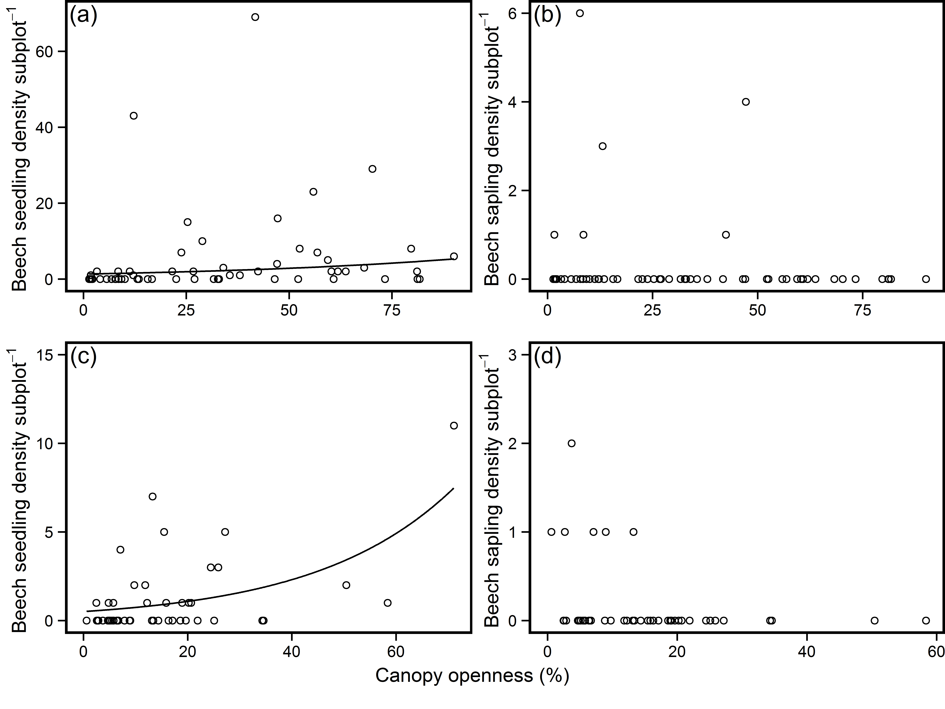

Figure 1 – Relationship between density of beech (a, c) seedlings and (b, d) saplings and canopy openness in woodlands in the New Forest showing signs of dieback. Plots a & b use data collected from across the New Forest (12 sites), while plots c & d use data from Denny Wood. Solid lines represent predictions from coefficients with P ≤ 0.05.



Figure 2 – Relationship between subplot stem density and total subplot basal area. Points represent individual plots in 1964 (red circles), 1996 (green triangles) and 2014 (blue squares). The solid line represents the prediction from a mixed model of this relationship with the grey band representing the coefficient 95% confidence intervals. Note that that both x and y axes are log transformed.

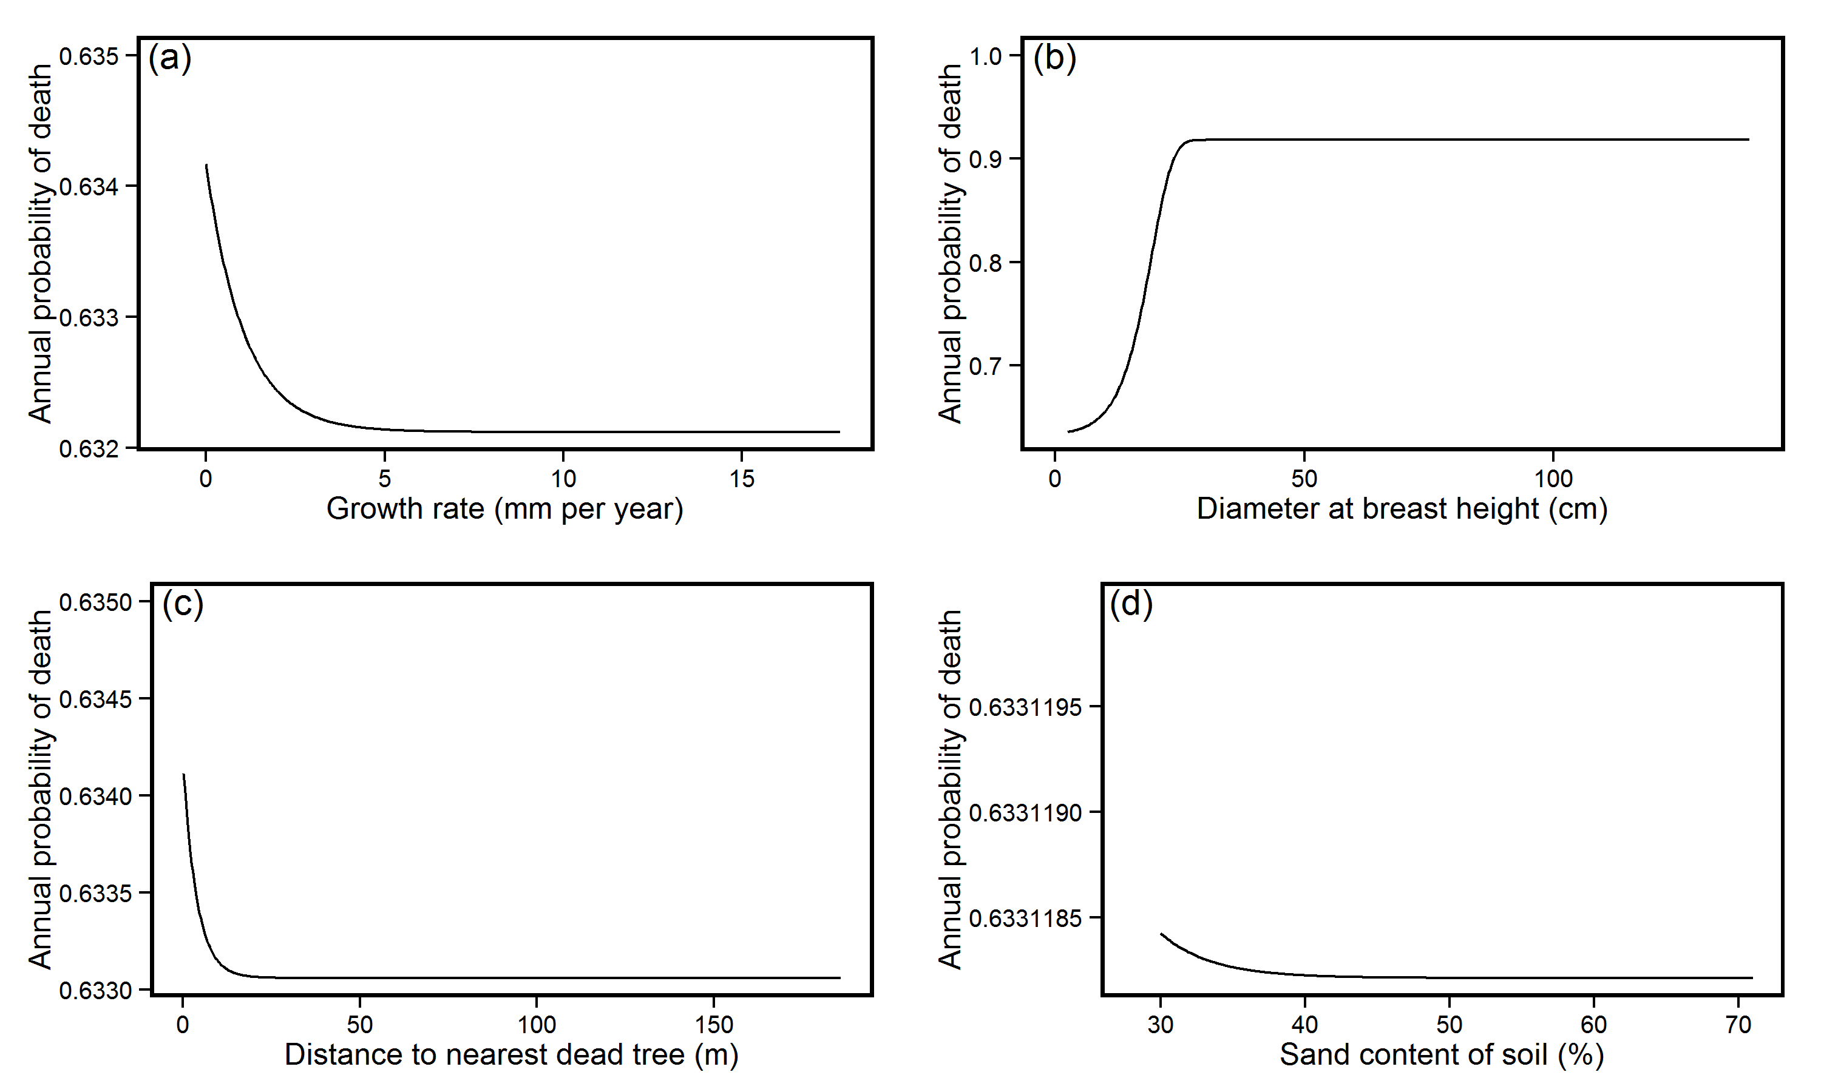

Figure 3 – Relationship between annual probability of beech tree death and (a) growth rate per year, (b) diameter at breast height (dbh), (c) distance to nearest dead tree and (d) sand content of soil. Lines represent predictions generated from model-averaged parameter estimates. Both growth rate per year and dbh were significant (p < 0.05) predictors of tree death. To produce predictions all variables were held at their mean apart from the variable of interest.

*do not have more than three significant figures in your numbers on the y axis

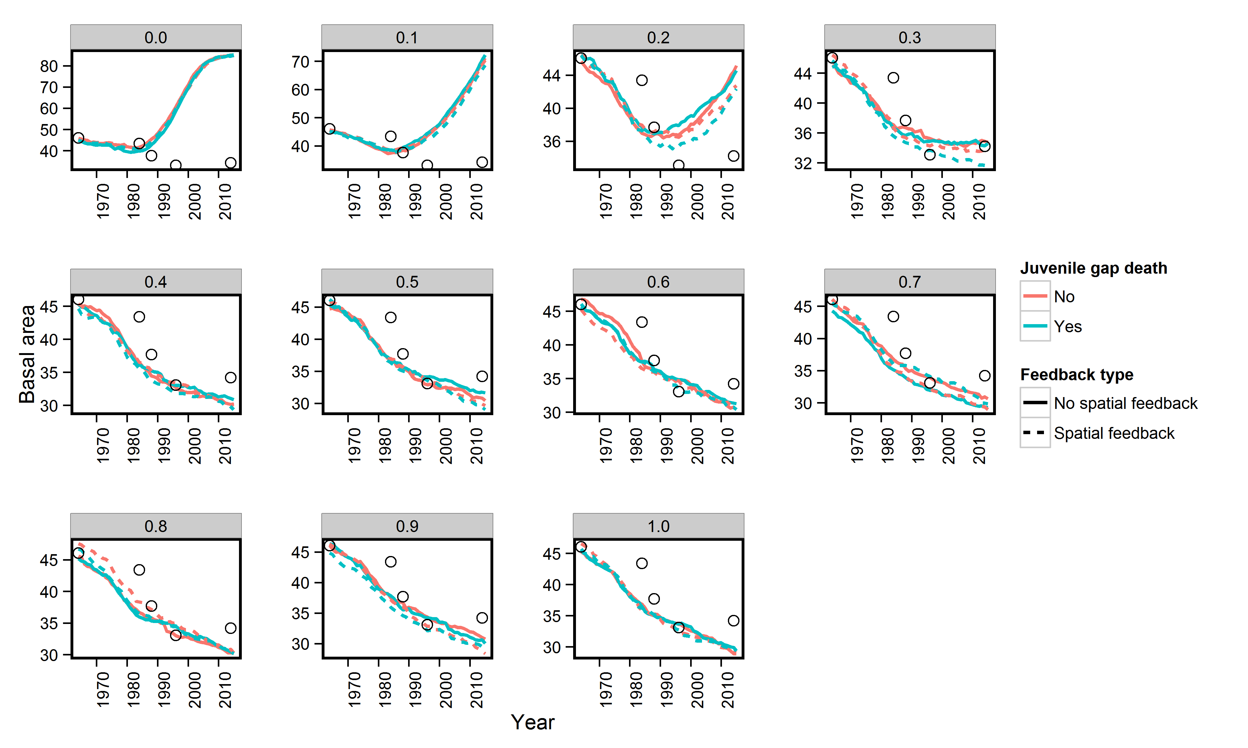

Figure 4 – The effect of feedbacks in mature tree death and juvenile mortality on predicted basal area from 1964 to 2014. Lines represent mean basal area (BA) at each modelled time step, with solid lines representing a model with no feedbacks and the dashed line representing a model with a spatial feedback in probability of death. Circes represent field observations from 1964 – 2014 to allow comparison between model results and actual data. Each graph represents a different annual chance of juvenile mortality, which is indicated numerically at the top of the graph.

I think you need to make these graphs a bit bigger. Maybe four rows with three figures in each. Also I think the Y axis scale needs to be the same in each case, this is a bit confusing otherwise.

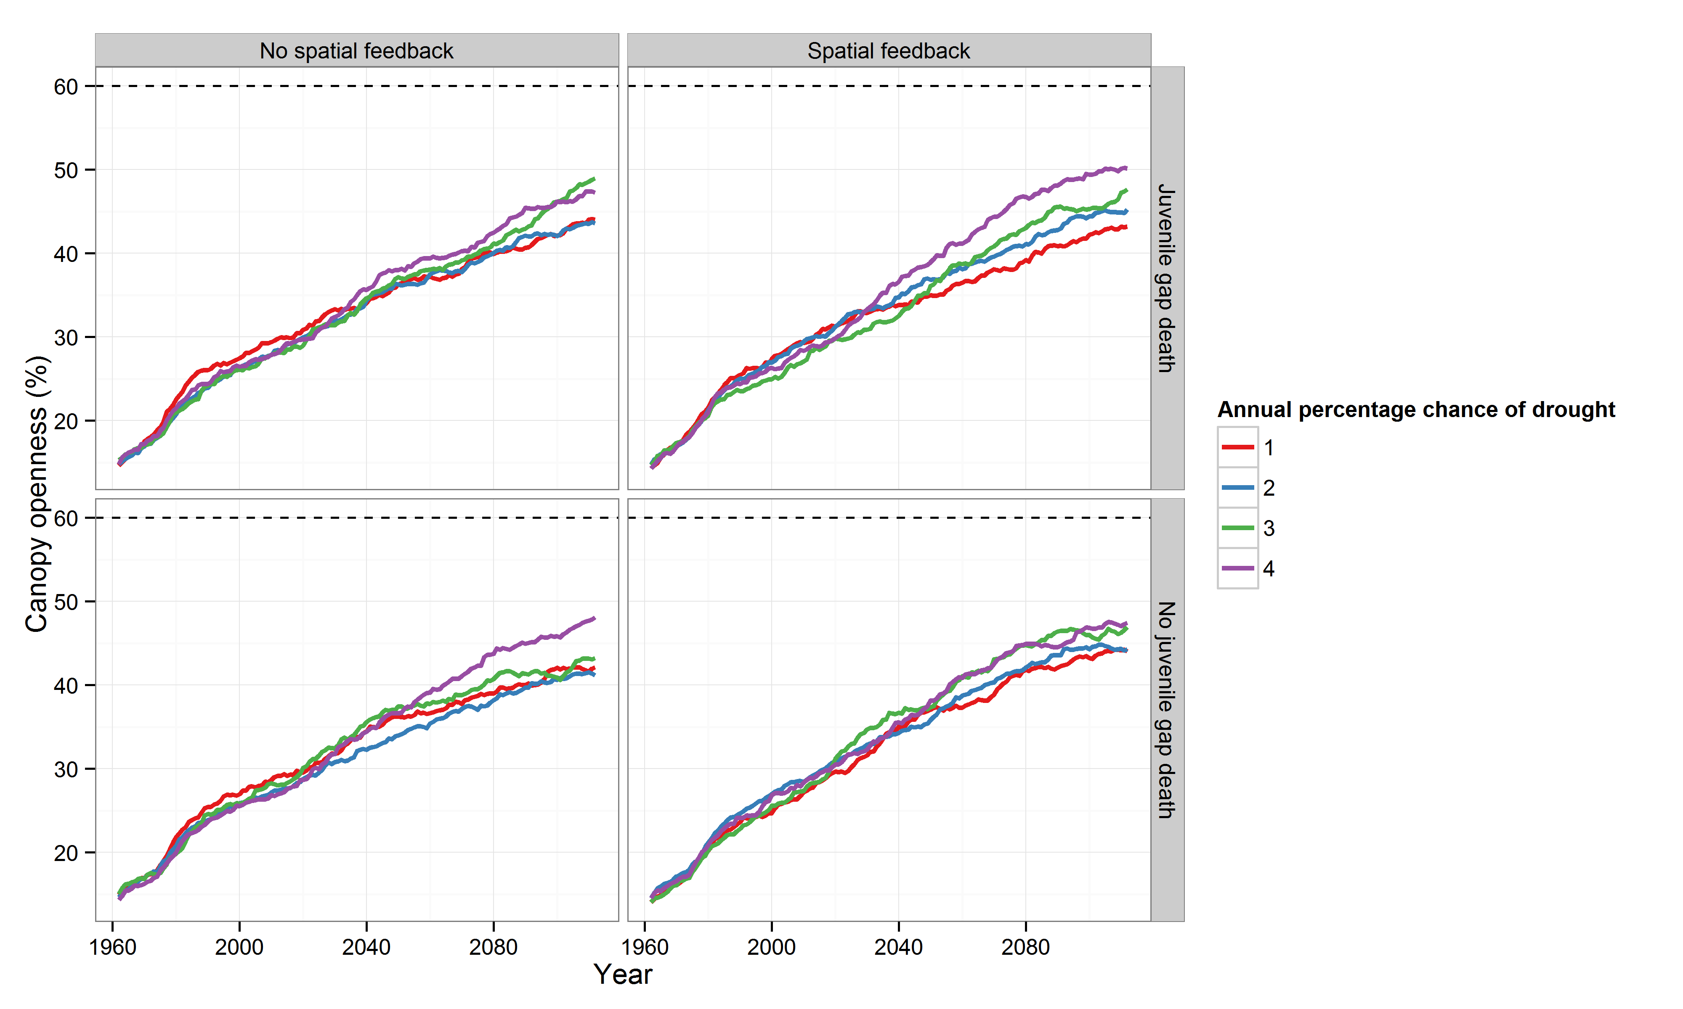

Figure 5 – The effect of feedbacks in mature tree death and juvenile mortality on predicted forest canopy openness from 1964 to 2114, using an individual based model. Lines represent median canopy openness at each model time step, with red, blue, green and purple lines representing 1, 2, 3, and 4% annual chance of severe drought respectively. Each panel represents a model with a different combination of feedbacks acting on juveniles and / or mature trees. The horizontal dashed line represents the threshold at which we define a non-forest state. This would be much more interesting if you changed the drought value so that it is high enough actually to generate a transition to a non-tree state. As it stands it isn’t showing much, is it? You need a much bigger range than 1-4, I think.

Table 1 – Summary of recruitment and mortality of beech saplings in Denny wood from 1964 to 2014

|  |  |  |  |  |  |  |
| --- | --- | --- | --- | --- | --- | --- |
| Census period | No. of saplings at T1 | No. of saplings recruited from seedlings | No. of saplings that died during census | No. of saplings that that increased beyond DBH 10 cm | Annual rate of increase to >10 cm DBH | Annual mortality rate of saplings |
| 1964-1984 | 179 | 3 | 101 | 25 | 0.75 % | 4.07 % |
| 1984-1988 | 56 | 1 | 6 | 11 | 5.32 % | 2.79 % |
| 1988-1996 | 40 | 2 | 6 | 13 | 4.79 % | 2.01 % |
| 1996-2014 | 23 | 1 | 2 | 14 | 5.08 % | 0.50 % |

Table 2 – Coefficients of beech tree mortality from 1964 to 2014 produced from model averaging of mixed effect complementary log-log models with ΔAICc ≤7.

|  |  |  |  |  |  |  |
| --- | --- | --- | --- | --- | --- | --- |
| **Variable** | **Estimate** | **Std. Error** | **Lower CI** | **Upper CI** | **p value** | **Importance value** |
| Intercept | -5.19 | 0.26 | -4.68 | -5.70 | <0.0001 | 1 |
| DBH | 0.23 | 0.11 | 0.45 | 0.01 | <0.046 | 0.8 |
| Distance to dead tree | -0.14 | 0.19 | 0.23 | -0.51 | 0.46 | 0.54 |
| Growth rate | -0.93 | 0.15 | -0.64 | -1.22 | <0.0001 | 1 |
| Sand content | -0.14 | 0.19 | 0.23 | -0.51 | 0.45 | 0.52 |

Table 3 – Parameter values for individual based model

|  |  |  |  |
| --- | --- | --- | --- |
| **Parameter name** | **Sources** | **How derived** | **Value** |
| Number of seedlings produced in mast year per tree | (Olesen & Madsen 2008) | Mean of number of seedlings present after a mast year divided by the number of mature beech trees in the woodland. | 82 (26) |
| Juvenile height growth rate in gaps | (Ammer *et al.* 2008) | Used values from reference | 12.6 cm year-1 |
| Juvenile height growth rate under closed canopy | (Ammer *et al.* 2008) | Used values from reference | 10.9 cm year-1 |
| Maximum juvenile density | (Olesen & Madsen 2008) | Used values from fenced, ungrazed plots | 3 seedlings m-2 |
| Mature tree mortality | This study | Derived from statistical analyses |  |
| Annual mature tree growth rate | This study | Derived from statistical analyses | 0.25 - (0.003*DBH) |
| Annual probability of mast year | (Packham *et al.* 2012) | In the UK beech trees mast once every three years on average | 0.3 |

**Supplementary material**

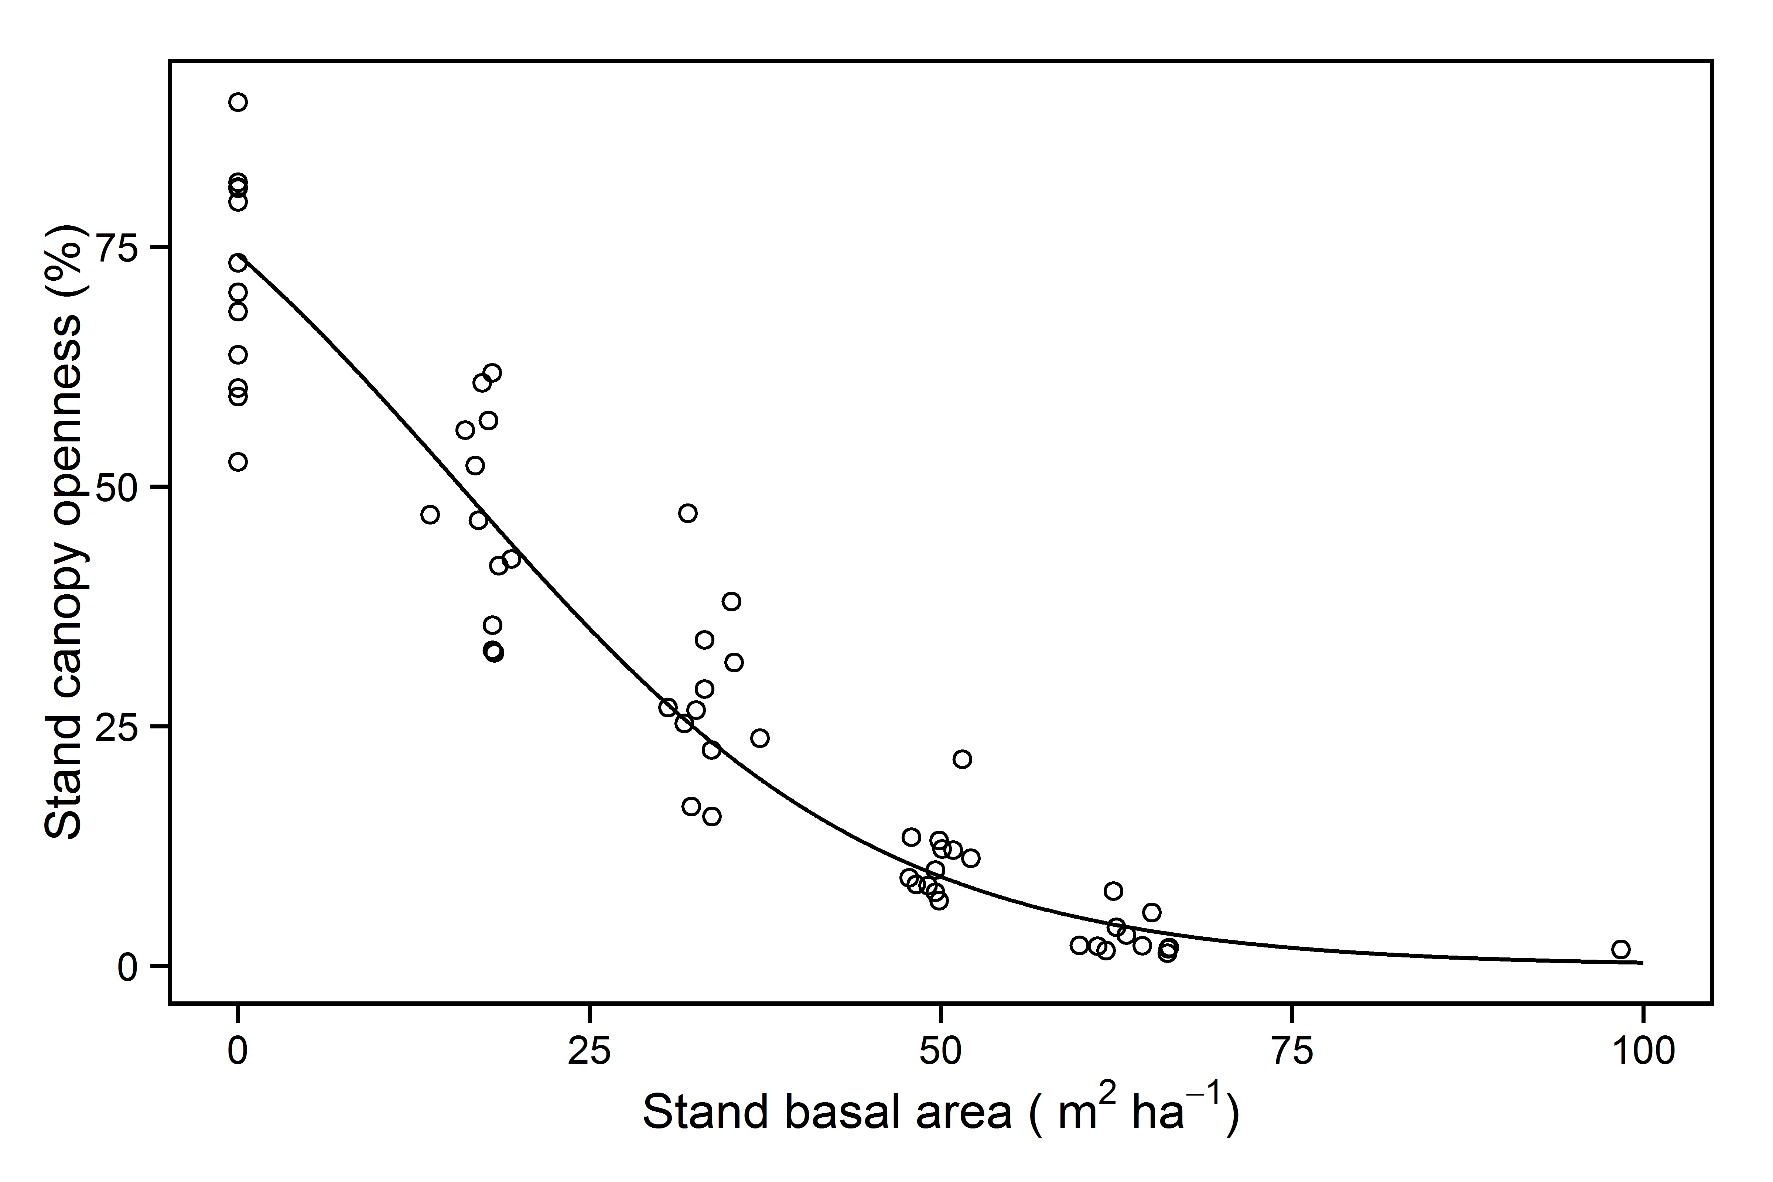

Figure S1 – Relationship between stand basal area and stand canopy openness in beech woodland in the New Forest. Data from Evans et al. (*In prep.*)